# Terms

## B2B vs B2C

**B2B** (Business-To-Business) refers to a business model in which one business sells products or services to another business. B2B transactions may involve large volumes, long-term contracts, and complex purchasing processes. Examples include manufacturers supplying components to other manufacturers, software companies providing enterprise solutions to businesses, or wholesalers selling products to retailers.

**B2C** (Business-To-Customer) refers to a business model in which one business sell products or services directly to the end-users or consumers. B2C transactions often involve lower volumes, simpler purchasing processes, and shorter sales cycles. Examples include retail stores, e-commerce platforms, restaurants, etc.

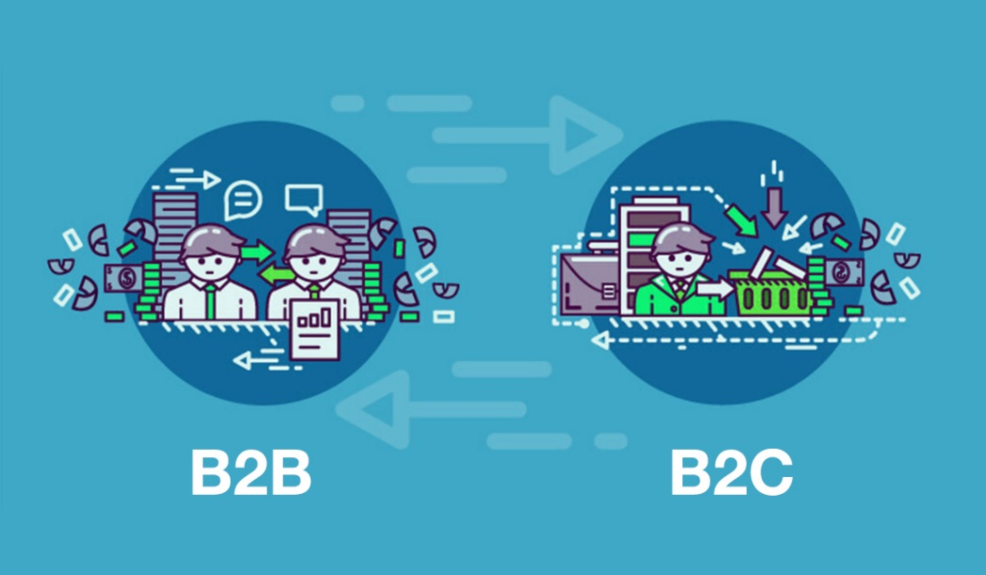

## OEM

**OEM** (Original Equipment Manufacturer) refers to a company that produces goods or components that are then used or resold by another company (known as a VAR – Value-Added Reseller) under its own brand name. In other words, OEM companies don’t sell directly to consumers but instead supply products to other businesses.

For example, Foxconn is an OEM that manufactures electronic components and devices for companies like Apple.

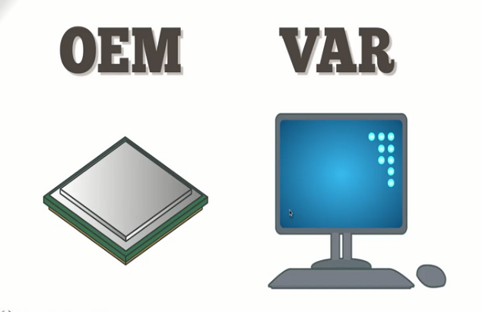

## NPI

NPI (New Product Introduction or New Product Development) refers to **the process of bringing a new product or service from concept to market launch**. It typically involves various stages and activities aimed at planning, developing, testing, production, and launching the product successfully.

# Assessment Model

## SPICE

SPICE (Software Process Improvement and Capability Determination) is a **framework and assessment model used to evaluate and improve software development processes within organizations**. It aims to enhance the quality, efficiency, and effectiveness of software development by providing a structured approach to process improvement.

SPICE is based on the ISO/IEC 15504 standard. It’s developed in 2001 by the AUTOSIG (Automotive Special Interest Group - VDA) in the European.

SPICE provides a set of guidelines and criteria for assessing and improving software processes. Its key components include:

* **Process Assessment**: SPICE involves assessing the maturity and capability of software development processes within an organization. This assessment is typically conducted through a systematic evaluation of process attributes, such as process performance, process management, and process improvement.
* **Capability Levels**: SPICE defines 6 capability levels that reflect the maturity and effectiveness of Software Development Life Cycle (SDLC). These levels range from Level 0 (incomplete process) to Level 5 (optimizing process). Each capability level represents a higher degree of process maturity and capability.
* **Process Improvement**: SPICE provides guidance on how to improve software development processes based on the assessment results. It helps organizations identify areas for improvement, set improvement goals, and implement best practices to enhance their processes.
* **Best Practices and** **Models**: SPICE incorporates best practices and reference models to guide organizations in the improvement of their software development processes. These may include industry standards, process models, and frameworks such as CMMI (Capability Maturity Model Integration) or ISO/IEC 12207 (Software Life Cycle Processes).

The benefits of SPICE include:

* Enhanced process efficiency and effectiveness
* Improved product quality and reliability
* Better project management and risk control
* Increased customer satisfaction
* Standardization and consistency in software development practices
* Continuous process improvement and organizational learning

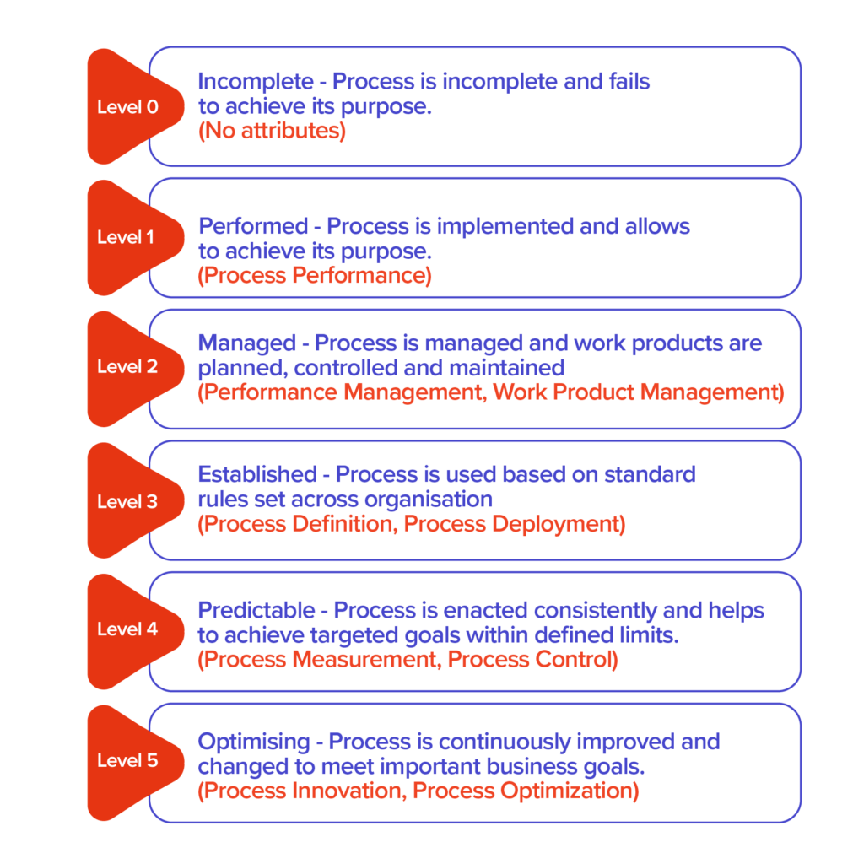

*Five maturity levels of SPICE*

## ASPICE

ASPICE (Automative Software Process Improvement and Capability Determination) or **Automotive SPICE** is a **framework and assessment model specifically tailored for the automotive industry.**

It’s built on the V model which comes as a sequence of requirements flowing down from the System to the Hardware and Software and then testing building up as software and hardware is integrated with the sub-systems and finally into the vehicle.

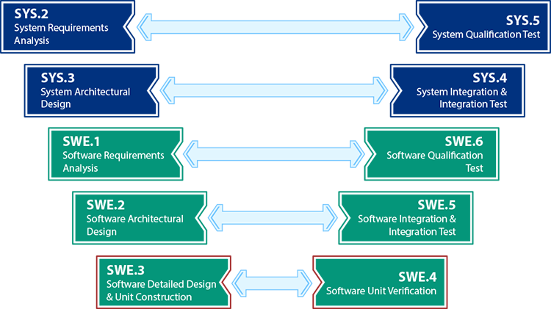

*Automotive SPICE V-model (short)*

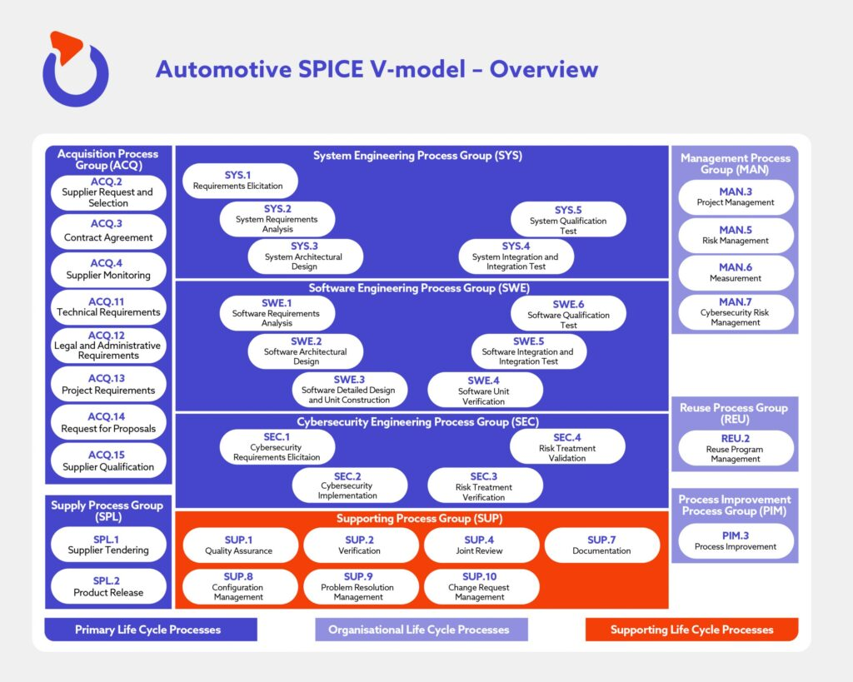

*Automotive SPICE V-model (full)*

## CMMI

CMMI (Capability Maturity Model Integration) is a **process improvement framework and assessment model** that provides organizations with guidelines for improving their software development and management processes. It helps organizations enhance their capabilities and achieve higher levels of maturity in delivering quality products and services.

CMMI was developed by the Software Engineering Institute (SEI) at Carnegie Mellon University in the US. It combines the best practices from several earlier models, including the Capability Maturity Model (CMM) and the Software Capability Maturity Model (SW-CMM).

The key characteristics and components of CMMI include:

* **Maturity Levels**: CMMI defines 5 maturity levels that represent different stages of process improvement and organizational maturity. They are:
* Level 1: Initial - Processes are ad hoc and unpredictable.
* Level 2: Managed - Basic project management practices are established.
* Level 3: Defined - Standardized processes are defined and implemented across the organization.
* Level 4: Quantitatively Managed - Processes are measured and controlled using quantitative techniques.
* Level 5: Optimizing - Continuous process improvement is ingrained in the organization's culture.
* **Process Areas**: CMMI defines a set of process areas that cover different aspects of software development and management. These process areas include requirements management, project planning, configuration management, measurement, analysis, and many others. Each process area has specific goals and practices that organizations should strive to achieve.
* **Appraisal Method**: CMMI provides an appraisal method that allows organizations to assess their process capabilities against the CMMI model. This appraisal can be conducted internally or by an external appraisal team. The appraisal results provide insights into the organization's strengths, weaknesses, and areas for improvement.
* **Continuous Improvement**: CMMI promotes a culture of continuous improvement by emphasizing the importance of monitoring, measuring, and analyzing process performance. It encourages organizations to identify areas of improvement, set improvement goals, and implement changes to enhance their processes.

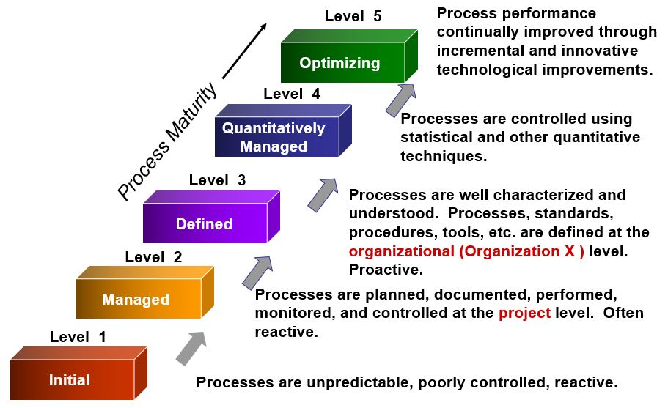

*Five maturity levels of CMMI*

The benefits of adopting CMMI include:

* Improved process efficiency and effectiveness
* Enhanced product quality and reliability
* Better project management and risk control
* Increased customer satisfaction
* Standardization and consistency in software development practices
* Improved organizational performance and competitiveness

## SPICE vs CMMI

Both ASPICE and CMMI cover the 4 categories of Process Areas within automotive software development (process management, project management, engineering and support), but at different depth. Also, CMMI has a broader scope of application than ASPICE. CMMI covers certain process areas that ASPICE doesn’t.

ASPICE is focused on the engineering practices according to the V-model at a project level, not only software engineering but also systems engineering (software + hardware, electronics, mechanical, etc.). CMMI is oriented towards project management and other organisational practices at a company level.

# SW Development Process In Smart Business Unit (LG)

SW Development Process in Smart Business Unit defines SW development phase and is specialized in automative industry and B2B development.

It is developed based on NPI and ASPICE process model.

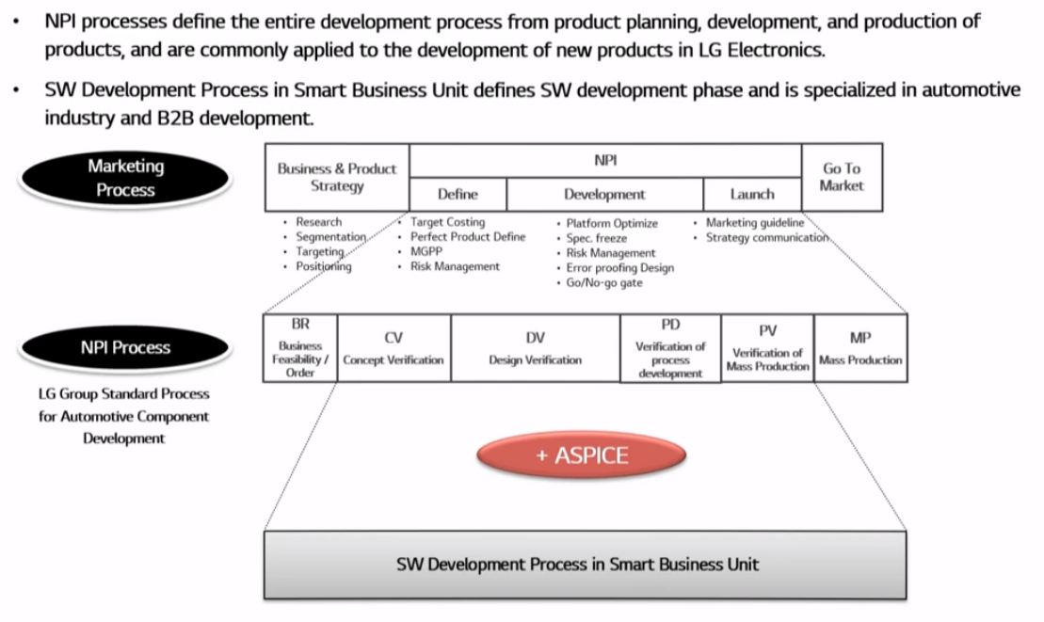

It’s composed of **21 areas** which are further divided to Core Area and Additional Area:

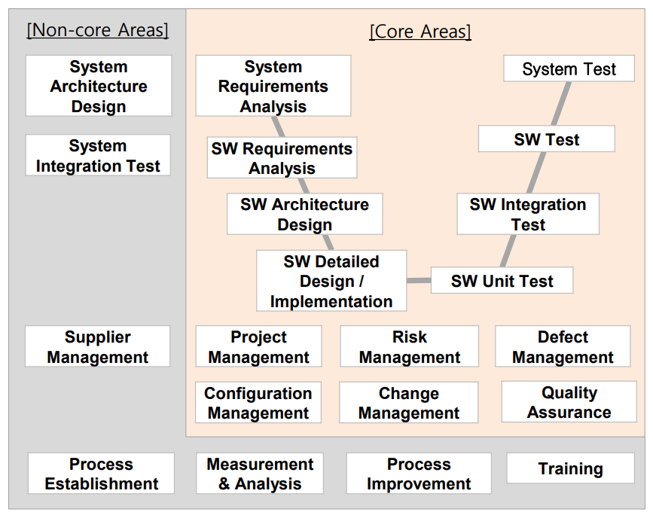

It’s further divided into **4 phases with** **40 detailed activities**:

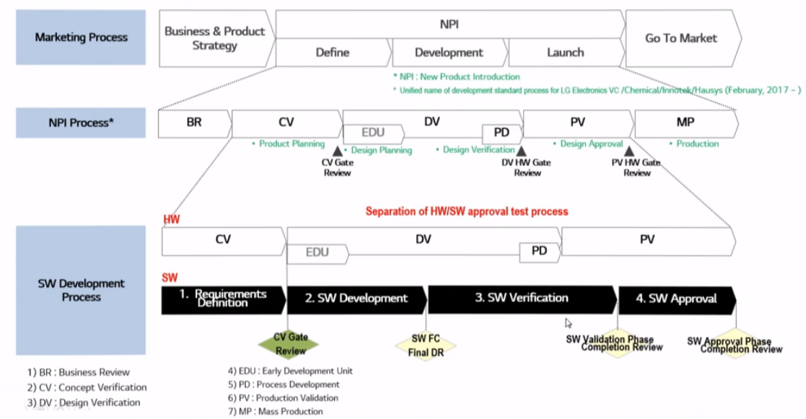

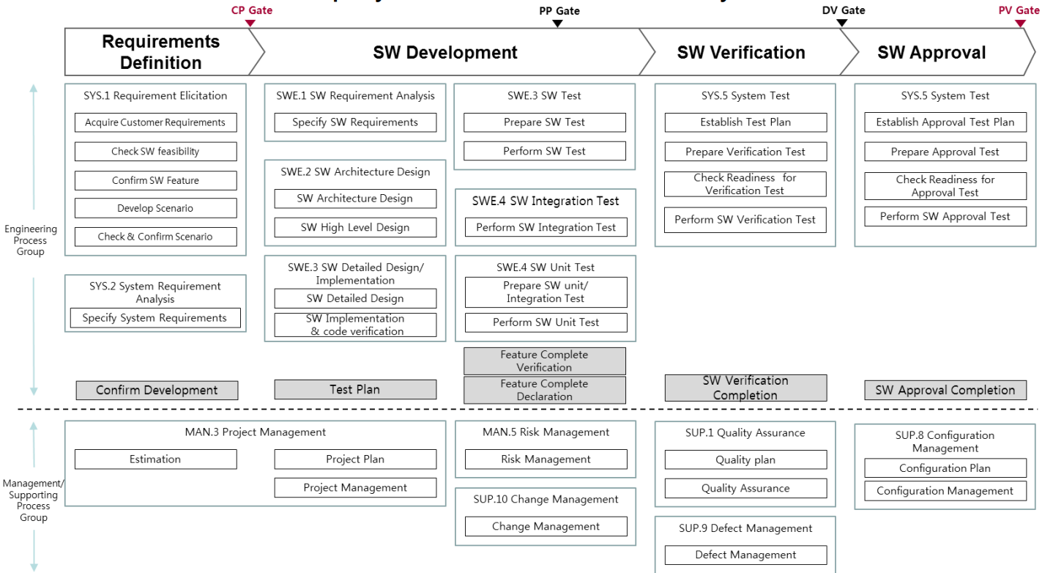

## Phases

### Requirement Definition

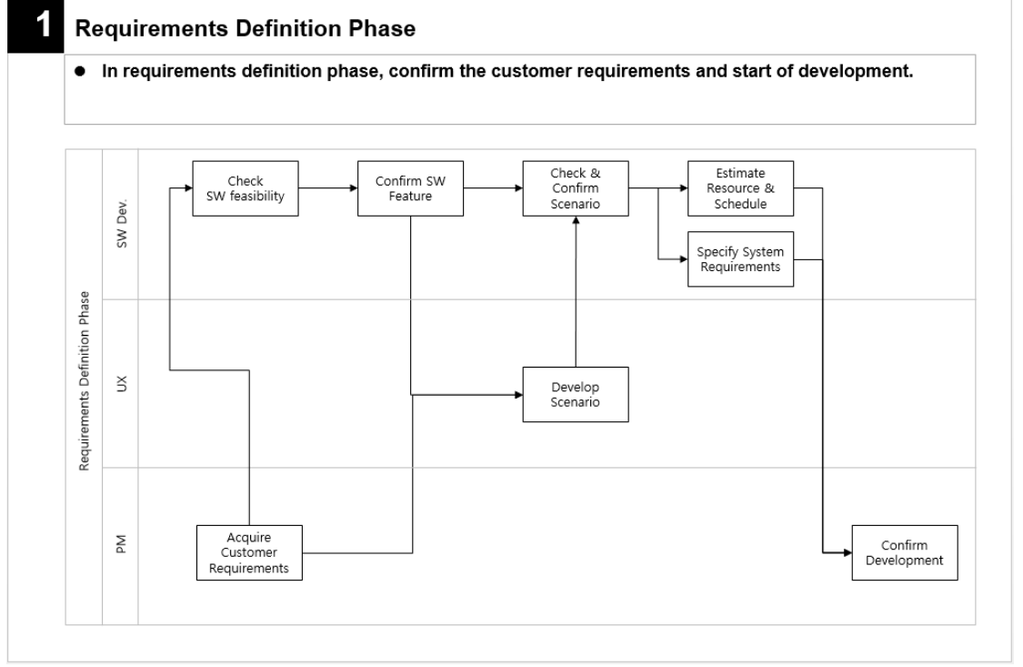

### SW Development

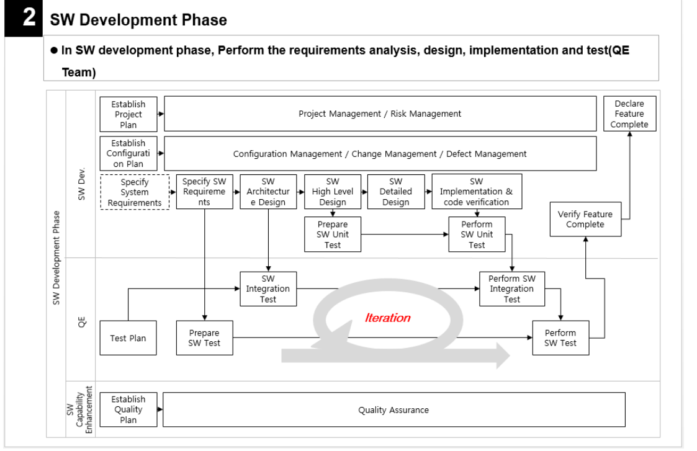

### SW Verification

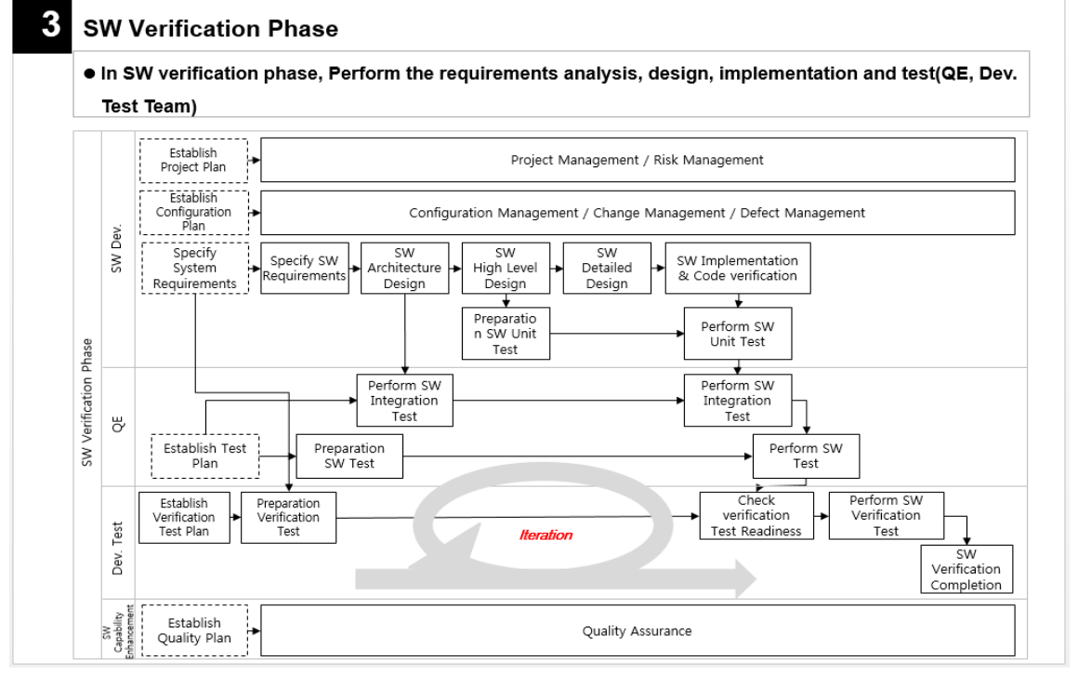

### SW Approval

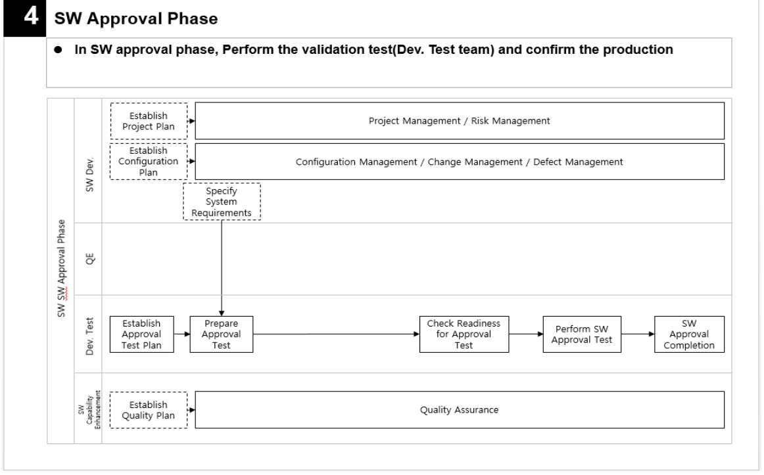

## Department in Charge for Each Area

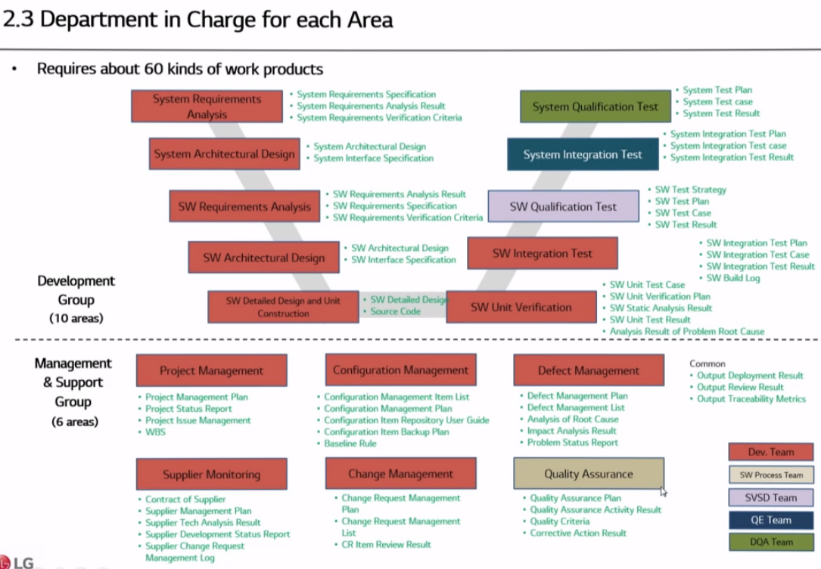

# Static Analysis (LG)

## Process

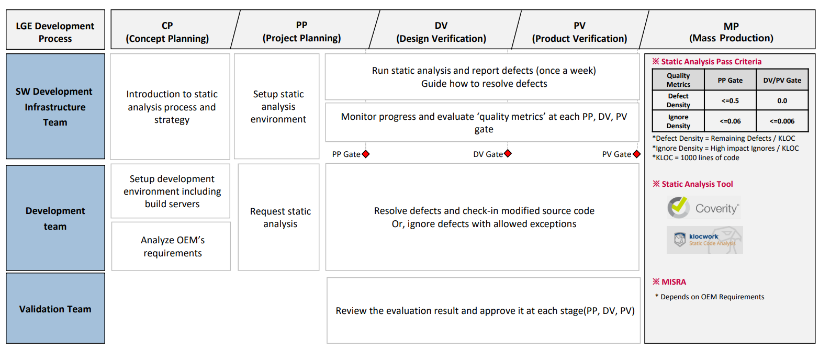

## Workflow

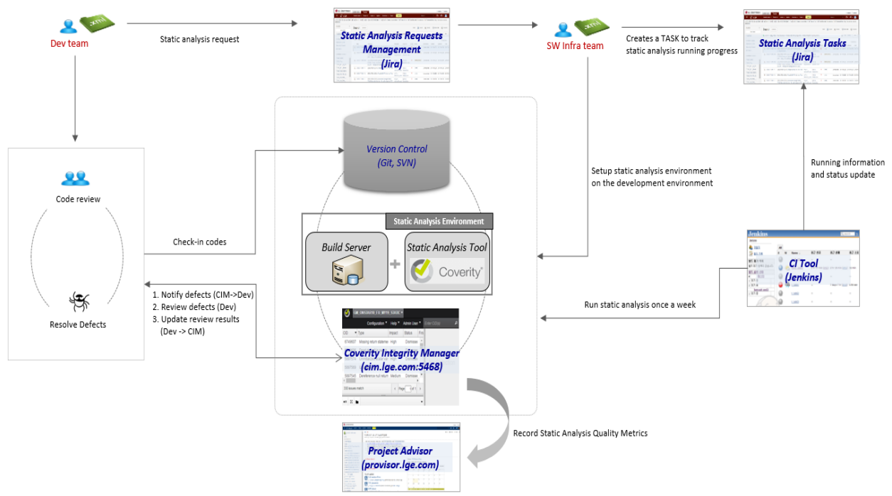

## Defect Lifecycle

